Wellbeing Wednesday: 15th April 2020
Message for parents and learners,
Welcome to another Wellbeing Wednesday, where we would like to encourage you to try a new Enrichment Activity, the Well-being Challenge, or just enjoy time with your family in your homes. Thank you to all who have sent in photos of their work, you have been incredibly creative!
Every Wednesday we will have a
- selection of Enrichment Club activities to try out,
- the Weekly Wootton Wellbeing Challenge, or
- why not try an Extended Project!
This week’s Enrichment Club activities:
- The art of creating Mandala patterns
- Bubble Trouble- who can make the biggest bubble snake?
- The Origami Challenge
- Why not create your own Enrichment Club?
  - Think of an interesting activity aimed at either the Primary Phase, or Secondary Phase.
  - Create a guide with examples
  - Submit it to Miss Watts… you never know, your Enrichment Club idea could be on next week’s Wellbeing Wednesday activity list!
Attached you will find useful instructions, and links to websites to help you with some of the tasks. If you create something you are proud of, why not send a photograph of your work to info@woottonparkschool.org.uk
A selection of the work will be placed on the website for all to see!
Kind regards
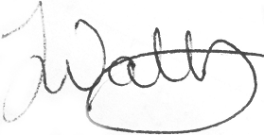
Jennifer Watts
Assistant Principal
Wootton Park School

